**The Three Divisions of the Old Testament and the Three Divisions of the New Testament**

|  |  |  |  |  |  |
| --- | --- | --- | --- | --- | --- |
| **Adam to Abraham** | **Abraham to Moses** | **Moses to Malachi** | **The Gospel Period** | **The Acts Period** | **The Post Acts Period** |
| **Genesis 1 - 11** | **Genesis 12 – Exodus 19** | **Exodus 19 – End of OT** | **The Gospels** | **The Acts & early letters** | **The later letters** |
| All peoples equal.  No such thing as  Jew & Gentile | Abraham’s seed to be first; Genesis 12:1-3 is  The Abrahamic Covenant. Abraham, Isaac, Jacob / Israel - Joseph | Israel / Jews first | Almost exclusively  to the Jews | The Jews first,  and also to the Gentile,  but note the two groups of Gentiles: the God-fearers and the pagans | All believers equal.  No such thing as  Jew & Gentile |
| No Mosaic Law | No Mosaic Law  The Code of Hammurabi;  Then the Laws of Egypt | The Mosaic Law  Given in Exodus, Leviticus & Deuteronomy:  note Deuteronomy 28 | The Mosaic Law | The Mosaic Law for Jewish Christians but not for Gentile Christians who were to observe the four rules of the Jerusalem council | Mosaic Law cancelled |

|  |  |  |  |
| --- | --- | --- | --- |
| ***The Gospel***  ***Period*** | ***The Acts*** | ***Period*** | ***The Post Acts***  ***Period*** |
| The Gospels | The Acts of and the | of the Apostles  Earlier Letters | The Later Letters |
| Almost  exclusively  Jewish | ***To the Jew first ... and*** | ***also ...***  ***to the Gentiles*** | All believers equal.  No such thing as  Jew & Gentile |
|  | Letters to Jewish Christians | Paul’s earlier letters  to Jewish and Gentile Christians | Paul’s later  letters |
| Matthew  Mark  Luke  John | Hebrews  James  1 & 2 Peter  1, 2 & 3 John  Jude  Revelation | Romans  1 & 2 Corinthians  Galatians  1 & 2 Thessalonians | Ephesians  Philippians  Colossians  1 & 2 Timothy  Titus  Philemon |

Three good books

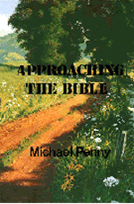**Approaching the Bible**

**Michael Penny ($18.75**)

This book explains clearly how we need to Approach the Bible if we are to make sense of what God has said. It does so in an easy to read style and with an easy to understand method.

Michael Penny does and excellent job in following and explain the advice of Bishop Miles Coverdale; advice which was contained in the first Bible printed in English.

That advice was based on asking such questions as:

|  |  |
| --- | --- |
|  | * "Who" were the words written to, or "Who" were they about? * "Where" is this to take place? * "When" was it written or "When" is it about? * "What", precisely, is said, taking into account the context? * "Why" did God say it, do it, or will do it? |
|  |
|  |
|  |
|  |

After asking such questions, we will then have a better understanding of what a passage of the Bible means and can "**Apply**" that passage to our lives today.

Please send me:

_____ copies of *Approaching the Bible* at $15.95

_____ copies of *40 Problem Passages* at $15.95

_____ copies of *The Will of God: Past and Present* at $15.95

_____ **free copy** of *Search magazine* edited by Michael

Penny

**40 Problem Passages**

**Michael Penny**

**($25.00)**

This book is a sequel to Michael Penny’s earlier book [***Approaching the Bible***](http://www.obt.org.uk/Publications/Books/ApproachingBible.htm)***.*** It applies the principles set out there to *40 Problem Passages* from the Bible, but there are far more that 40 Problem Passages in the Bible!

However, in this book Michael Penny not only solves these 40 Problem Passages, he also equips the reader with a method by which many, many more problem passages can be understood and successfully applied to the life of a believer today. Some of the passages and subjects considered include:

* Genesis 4: The Cain Complex
* Judges 11: Jephthah’s daughter
* Daniel 9: Seventy sevens
* Matthew7: Ask and you will receive
* Matthew 10: Do not go among the Gentiles
* Matthew 24: This generation shall not pass away
* Luke 12: The unforgiveable sin
* John 14: I will do whatever you ask in my name
* Romans 1: The Gospel: first for the Jew
* 1 Corinthians 7: Do not look for a wife
* Revelation 13: 666

- and many more.

Your name _________________________________

You address ________________________________

__________________________________________

Please make cheques payable to

‘BBFA Book Agency’.

Please send your order and cheques to:

BBFA Book Agency,

P O Box 3141, Glendale, NSW 2285

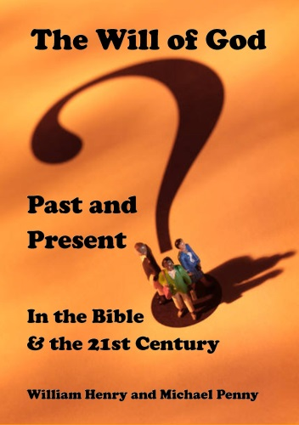**The Will of God: Past and Present**

**Michael Penny ($20.00)**

The Will of God is an important subject and this book concentrates on what theologians call the ‘preceptual’ will of God. This aspect of God’swill deals with what He would *like* to happen, in terms of the way He would like us to live our lives.

In the Introduction to the book the authors write:

It is imperative in the study of any subject to consider *all* that the Bible has to say.

This we have attempted to do by starting in Genesis and working our way through the Bible chronologically**.**

We have also paid attention to when new aspects of the will of God appear, and to when they change.

In the New Testament, we have also taken special care to distinguish between the will of God for Jews and His will for Gentiles. Sometimes it is the same … but not always.

As such the first section works its way chronologically through the Old Testament … first considering the Pentateuch and then the Historical books, before dealing with the Psalms, Proverbs and the Prophets.

The New Testament section deals with the Gospels and Acts, and then the letters – splitting them into the Jewish letters and Paul’s letters.

The final section applies what has been learnt to the 21st Century.

Visit www.obt.org.uk